

Functional Requirements and Conceptual Design for Discount Authorization Approval Flow

Projects | USME – Ascent Rental Salesforce CRM Implementation
Prepared For | USME
Document Status

Document Change Control Log:
The Document Change Control Log is updated each time the document is modified. The log identifies the version number, the date of revisions, a brief description of the changes, and the author/reviewer
Version # | Date | Description | Author | Summary of Changes
V1.0 | July 21, 2026 | Functional Requirements and conceptual Design | Durvah | Initial draft based on Commercial Deal Framework, Strategic Value Score Guide, and Pricing/Discount Authorization deck
V1.1 | October 28, 2026 | Functional Requirements and conceptual Design | Durvah | Finalized Framework Update: Replaced the 5-dimension Authority Matrix with a streamlined two-track commercial policy (Track A: List-Price Driven Rentals and Track B: GPO Contract Driven Rentals). Updated eligibility guardrails, dollar-based approval tiers, data model, validation rules, and Flow logic.

Approvals from USME Team:
Version # | Date | Approver Role | Approver

Executive Summary
USME is implementing a system-enforced Custom Pricing and Discount Authorization Framework in Salesforce Sales Cloud to protect list-price integrity, govern margin realization, and establish a full audit trail ahead of a potential exit within the next two years.
In Version V1.0, the design relied on a five-dimension "most-restrictive-factor-wins" matrix evaluating discount depth, deal size (ACV), gross margin vs. floor, contract term, and non-standard concessions simultaneously
Version V1.1 finalizes and simplifies this framework into a cleaner, two-track commercial policy:
- Track A - List-Price Driven Rentals: Separates Discount Eligibility (governed strictly by minimum rental commitment in months) from Approval Authority (governed strictly by total discount dollars). Both conditions must be met before a quote can be finalized.
- Track B - GPO Contract Driven Rentals: Honors negotiated Group Purchasing Organization (GPO) contract rates automatically regardless of transaction size, while restricting additional discounts below GPO rates to deals of $100,000 or more with at least a 6-month commitment (routed to CRO + Deal Desk), blocking sub-$100K exceptions from the standard workflow unless approved directly by the Deal Desk.

Functional Requirements

2.1 Track A: List-Price Driven Rentals
For standard rentals anchored to the USME List Price Book, the system enforces a sequential two-gate evaluation:

Gate 1: Rental Commitment Eligibility (Maximum Discount % )
A salesperson may only request a discount percentage up to the maximum threshold permitted by the customer's minimum rental commitment term. Meeting the commitment threshold makes the discount eligible to be requested, not automatically approved.

Minimum Rental Commitment | Standard Max Discount Eligible (%) | Extended Consideration Cap (%) | System Enforcement Behavior
Open-ended / Under 3 months | 3% | N/A | Hard block in standard workflow if Discount % > 3%.
3–5 months | 5% | N/A | Hard block in standard workflow if Discount % > 5%.
6–11 months | 8% | N/A | Hard block in standard workflow if Discount % > 8%.
12+ months | 1% | Up to 15% (subject to approval & profitability) | Standard eligibility up to 10%. Discounts between 10.01% and 15.00% require profitability/margin verification and approval; hard block above 15%.

Gate 2: Total Discount Dollars Approval Authority
Once Gate 1 (Rental Commitment Eligibility) is satisfied, Salesforce calculates the Total Discount Dollars across the quote and determines the required approval authority:
Approval Tier | Total Discount Dollars ($) | Required Approver Role | Routing Behavior
Tier 1 | $0.00 – $2,500 | Sales Rep  (Self-Serve / Auto-Approve if Eligible) | Instant, at quote
Tier 2 | $2,500.01 – $5,000.00 | RSD  (Regional Sales Director ) | 4 business hours
Tier 3 | $5,000.01 – $25,000.00 | EVP  (Executive Vice President) | 1 business day
Tier 4 | $25,000.01 – $50,000.00 | CRO + Deal Desk | 2 business days
Tier 5 | Over $50,000.00 | CFO / CEO | Executive cadence

2.2 Track B: GPO Contract Driven Rentals
For customers purchasing under an active GPO contract, the system enforces contract rate integrity while gating incremental concessions:
Scenario | Eligibility Criteria | System Routing & Approval Authority
Standard GPO Pricing | Customers receive a negotiated GPO rate (0% additional discount below GPO price), regardless of transaction size or rental term. | Tier 1 (No additional approval required) — Validated against contract terms and auto-approved.
Additional Discount Below GPO Price (Standard Workflow) | Total Rental Deal Value $≥$ $100,000 AND Minimum Rental Commitment $≥$ 6 months. | Tier 4 — CRO + Deal Desk approval required.
Additional Discount Below GPO Price (Exception < $100K) | Total Rental Deal Value < $100,000 (or commitment < 6 months). | Blocked from Standard Workflow. Requires an explicit Deal Desk Exception Request and Deal Desk approval.

2.3 Retained Governance & Audit Requirements
The following foundational governance rules from Version 0.1 remain active across both tracks:
- Mandatory Reason Code & Expiration Date: Every non-zero discount requires a structured Reason Code, justification text, and an Expiration Date before quote submission or activation.
- Profitability & Margin Floor Protection: Gross Margin % and $ are calculated on every quote against FP&A's Product Family Margin Floor table. Any deal priced below its product-family margin floor—or utilizing the 10.01%–15% extended discount consideration on a 12+ month commitment—triggers mandatory Finance/Deal Desk visibility.
- Concession Costing: Free rental periods and waived fees are treated as discounts and factored directly into Total Discount Dollars and Gross Margin calculations.
- Strategic Value Score: Captured via 8 custom fields (totaling 0–20) on the Opportunity/Quote as read-only decision context for approvers without altering automated tier routing.
- Immutable Audit Trail: Every approval, rejection, recall, or exception override is written to a custom Approval_Override_Log__c object.

Salesforce Technical Design & Architecture

3.1 Out-of-the-Box vs. Custom Build Mapping
Capability | Out-of-the-Box (Sales Cloud / CPQ) | Custom Build / Configuration Required (v1.1 Update)
Pricing Track & Contract Pricing | Standard Price Books & Price Book Entries, CPQ Contracted Prices (if CPQ licensed). | Pricing_Track__c picklist (List Price, GPO Contract) on Quote; GPO_Contract_Price__c field on Quote Line Item to track baseline GPO rate vs. requested price.
Commitment Eligibility Gate (Gate 1) | None native. | Custom Metadata Type Commitment_Eligibility_Rule__mdt storing min/max months and max eligible discount %; Validation Rules blocking ineligible standard submissions.
Discount Dollar Tiering (Gate 2) | Standard Roll-Up Summary / Formula fields for Discount $. | Custom Metadata Type Discount_Dollar_Tier__mdt mapping Total Discount $ ranges to Tiers 1–5; before-save/after-save Record-Triggered Flow to stamp Required_Approval_Tier__c
GPO Below-Contract Gate | None native. | Flow decision logic & Validation Rules checking Net_Deal_Value__c >= 100000 and Commitment_Months__c >= 6 when Additional_GPO_Discount__c > 0
Approval Routing | Native Approval Process Engine or Advanced Approvals (if CPQ/Revenue Cloud is licensed) | Updated Role Hierarchy and Queues (RSD, EVP, CRO_Deal_Desk_Queue, Executive_CFO_CEO_Queue, Deal_Desk_Exception_Queue).
Audit & Expiration | Field History Tracking (limited). | Custom Approval_Override_Log__c object and Scheduled Flow to flag/deactivate expired discounts at renewal

3.2 Data Model & Custom Metadata Design

A. Custom Metadata Types (Configurable by Sales Ops without Code Deployment)

Commitment_Eligibility_Rule__mdt (Replaces 5-Dimension Matrix for Gate 1)
  - Commitment_Band_Label__c (Text): e.g., Open-Ended / <3 Months, 3-5 Months, 6-11 Months, 12+ Months
  - Min_Months__c (Number): 0, 3, 6, 12
  - Max_Months__c (Number): 2.99, 5.99, 11.99, 999
  - Standard_Max_Discount_Pct__c (Percent): 3.00%, 5.00%, 8.00%, 10.00%
  - Extended_Max_Discount_Pct__c (Percent): 3.00%, 5.00%, 8.00%, 15.00%

Discount_Dollar_Tier__mdt (Gate 2 Authority Table)
  - Tier_Level__c (Text): Tier 1, Tier 2, Tier 3, Tier 4, Tier 5
  - Min_Discount_Dollars__c (Currency): 0, 2500.01, 5000.01, 25000.01, 50000.01
  - Max_Discount_Dollars__c (Currency): 2500.00, 5000.00, 25000.00, 50000.00, 999999999
  - Approver_Role_Description__c (Text): Sales Rep, RSD, EVP, CRO + Deal Desk, CFO / CEO
  - SLA_Hours__c (Number): 0, 4, 8, 16, 40

Margin_Floor_By_Product_Family__mdt (Retained from v1.0)
  - Product_Family__c (Text), Target_Margin_Pct__c (Percent), Floor_Margin_Pct__c (Percent).

B. Core Quote / Discount Request Fields (Quote & QuoteLineItem / Discount_Request__c)
Field Label | API Name | Data Type
Pricing Track | Pricing_Track__c | Picklist
Rental Commitment (Months) | Rental_Commitment_Months__c | Number(3,0)
Commitment Category | Commitment_Category__c | Formula (Text)
Max Eligible Discount % | Max_Eligible_Discount_Pct__c | Formula (Percent)
Requested Discount % | Requested_Discount_Pct__c | Percent(5,2)
Total List / Baseline Value | Total_Baseline_Value__c | Currency
Total Discount Dollars | Total_Discount_Dollars__c | Currency
Net Deal Value (TCV) | Total_Contract_Value__c | Currency
GPO Exception Requested | GPO_Exception_Requested__c | Checkbox
GPO Exception Justification | GPO_Exception_Justification__c | Long Text
Eligibility Status | Eligibility_Status__c | Picklist
Required Approval Tier | Required_Approval_Tier__c | Picklist
Reason Code | Discount_Reason_Code__c | Picklist
Discount Expiration Date | Discount_Expiration_Date__c | Date

3.3 System Guardrails: Validation Rules
To prevent ineligible discounts from entering the standard approval workflow (in both Salesforce and Ascent), implement the following Validation Rules on the Quote

VR-01: Track A — Block Ineligible Discount % for Rental Commitment
Enforces Gate 1 (blocks >3% for <3 mo, >5% for 3–5 mo, >8% for 6–11 mo, and >15% hard cap for 12+ mo):
AND(
ISPICKVAL(Pricing_Track__c, "List Price Driven"),
OR(
AND(Rental_Commitment_Months__c < 3, Requested_Discount_Pct__c > 0.03),
AND(Rental_Commitment_Months__c >= 3, Rental_Commitment_Months__c < 6, Requested_Discount_Pct__c > 0.05),
AND(Rental_Commitment_Months__c >= 6, Rental_Commitment_Months__c < 12, Requested_Discount_Pct__c > 0.08),
AND(Rental_Commitment_Months__c >= 12, Requested_Discount_Pct__c > 0.15)
)
)
Error Message: "The requested discount percentage exceeds the maximum eligible discount for this rental commitment term (<3 mo: 3%, 3–5 mo: 5%, 6–11 mo: 8%, 12+ mo: 10% standard / 15% max with profitability approval). Please increase the rental commitment or reduce the discount."

VR-02: Track A — Require Profitability Justification for 10.01%–15% on 12+ Month Deals
AND(
ISPICKVAL(Pricing_Track__c, "List Price Driven"),
Rental_Commitment_Months__c >= 12,
Requested_Discount_Pct__c > 0.10,
Requested_Discount_Pct__c <= 0.15,
OR(
Margin_Floor_Met__c = FALSE,
ISBLANK(Justification__c)
)
)
Error Message: "Discounts between 10.01% and 15% on 12+ month commitments are only considered subject to profitability (Margin Floor Met) and a documented business justification."

VR-03: Track B — Block Sub-$100K or <6-Month GPO Additional Discounts in Standard Workflow
AND(
ISPICKVAL(Pricing_Track__c, "GPO Contract Driven"),
Requested_Discount_Pct__c > 0,
OR(
Total_Contract_Value__c < 100000,
Rental_Commitment_Months__c < 6
),
GPO_Exception_Requested__c = FALSE
)
Error Message: "Additional discounts below GPO contract rates require a minimum $100,000 deal size and a 6-month rental commitment. For truly exceptional requests below $100K, check 'GPO Exception Requested' and provide a Deal Desk justification."

VR-04: Track B — Require Justification on GPO Exception Requests
AND(
ISPICKVAL(Pricing_Track__c, "GPO Contract Driven"),
GPO_Exception_Requested__c = TRUE,
ISBLANK(GPO_Exception_Justification__c)
)
Error Message: "Please provide a detailed justification for the Deal Desk to review this sub-$100K GPO discount exception."

VR-05: Universal Governance Guardrails (Retained from v0.1)
AND(
Requested_Discount_Pct__c > 0,
OR(
ISBLANK(TEXT(Discount_Reason_Code__c)),
ISBLANK(Discount_Expiration_Date__c)
)
)
Error Message: "A Discount Reason Code and Discount Expiration Date are required on all discounted quotes."

3.4 Approval Process & Queue Routing Design

Calculated Tier | Routing Mechanism in Salesforce | Approver Action & Audit Logging
Tier 1 — Sales Rep | Auto-approved via Flow upon submission if Eligibility_Status__c = 'Eligible' and Total_Discount_Dollars__c <= $2,500 (or 0% additional discount on GPO). | Writes auto-approval entry to Approval_Override_Log__c; sets Quote status to Approved instantly.
Tier 2 — RSD | Routes via User Lookup / Role Hierarchy to the submitting rep's Regional Sales Director (RSD). | 4-business-hour SLA timer initiates; decision logged to Approval_Override_Log__c.
Tier 3 — EVP | Routes sequentially (RSD $→$ EVP) or directly to EVP based on Role Hierarchy. | 1-business-day SLA timer initiates; decision logged to Approval_Override_Log__c.
Tier 4 — CRO + Deal Desk | Routes to Deal_Desk_Queue (parallel or sequential sign-off by Deal Desk and CRO). Used for List-Price deals with >$25K-$50K discount dollars AND standard GPO below-contract deals ($≥$ $100K, $≥$ 6 mo). | 2-business-day SLA timer initiates; surfaces Margin Floor and Strategic Value Score (0–20) context.
Tier 5 — CFO / CEO | Routes through Deal Desk pre-screening to Executive_Approval_Queue (CFO / CEO). | Executive SLA cadence; mandatory rationale capture.
Deal Desk Exception | Separate exception path (GPO_Exception_Approval_Process) routing directly to Deal_Desk_Exception_Queue. | Allows Deal Desk to evaluate sub-$100K GPO exception requests outside the standard sales workflow.

4. Data Model
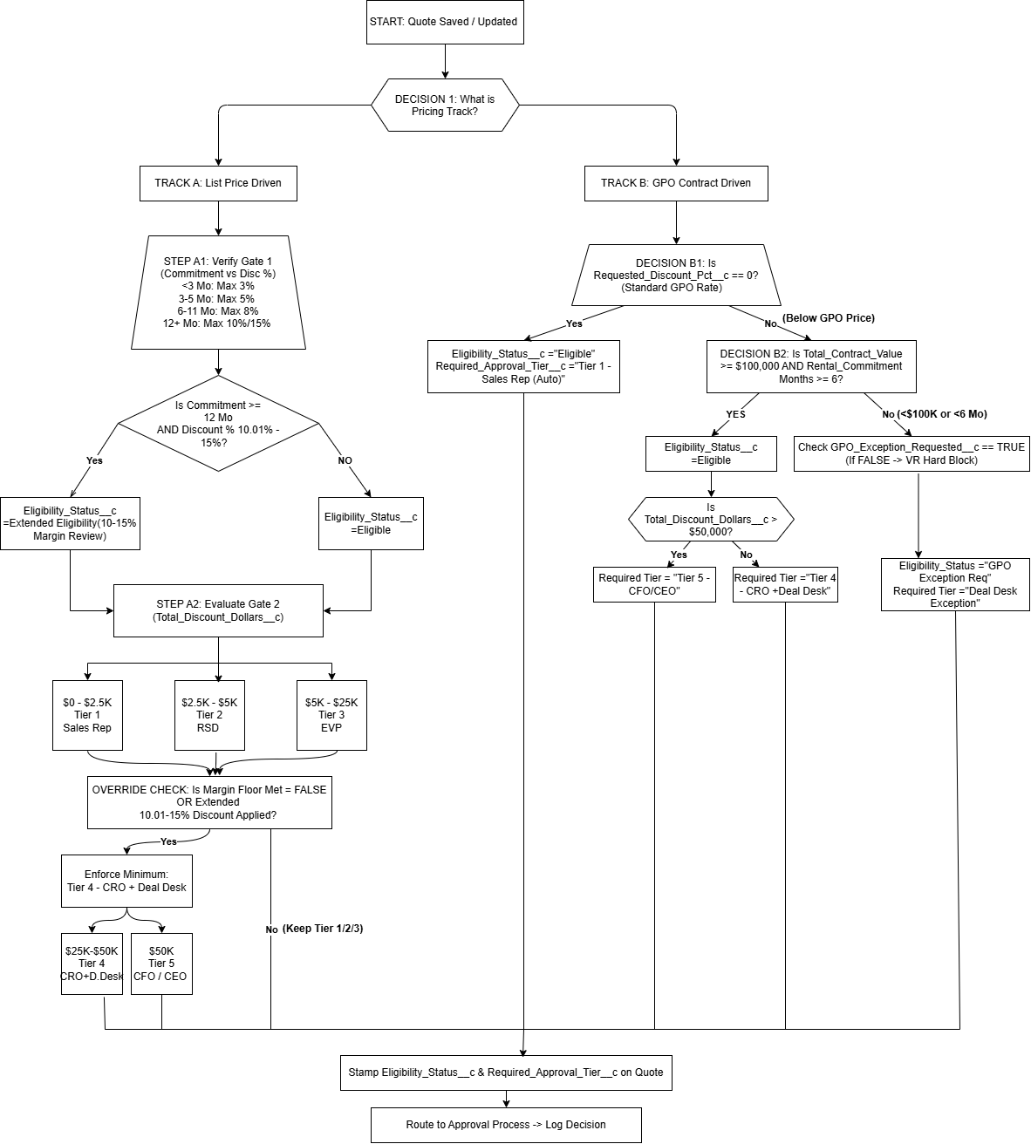

Open Questions:
To finalize the discount and approval workflow design in Salesforce, we need quick sign-offs on five business rules in review:
- 12+ Month Deals: Confirm if rep self-service stops at 10%, and 10.01%–15% requires Deal Desk exception review.
- Open-Ended Rentals: Agree on standard duration (e.g., 1 month) to calculate total discount dollars when no contract end date exists.
- Approval Sequences: Decide if higher-tier approvals skip straight to executive approvers or require sequential multi-manager sign-offs.
- Discount Scope: Confirm whether reps enter discounts at the overall quote header or per equipment line item.
- GPO Discount Ceiling: Confirm if there is a maximum allowable discount on GPO accounts before triggering CEO/CFO level approvals.

